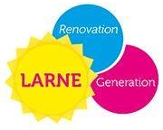

6:30-7:00pm: Christmas Carols. Join in the festive celebrations by singing Christmas carols at Broadway with the Church Singers
 | 7:00pm-7:50pm | 8:10pm-9:00pm
Aroma Coffee House | The powerful voice of Zolene Mayberry | Irish folk with Ray Moore
Berry Tree Café/ The Butter Churn | Irish folk with Ray Moore | Festive music from The East Antrim Accordion Group
Jenni Mac’s | The angelic voice of Erin Waugh | Soulful songs from Yasmin Andrews
Java Junkie | Festive music from The East Antrim Accordion Group | The angelic voice of Erin Waugh
Coffee Doc | Rock with Paul Sexton | Rock with Paul Sexton
Cafe Spice | Soulful songs from Yasmin Andrews | The powerful voice of Zolene Mayberry

